Psychology 110 - Hypnosis Module #10 2020

Student Outcomes:
Upon completion of this module, I will be able to:
___define hypnosis
___differentiate between the two major theories of hypnosis
___explain what posthypnotic suggestions are
___explain possible uses of hypnosis in psychology

Vocabulary: Are you familiar with these terms?
Hypnosis Social influence theory Divided consciousness theory
Posthypnotic suggestion

Hypnosis does not involve mind control, magic, unconsciousness or sleep. You cannot be made to enter hypnosis against your will. Hypnosis is a natural experience that happens to most of us each day when we become absorbed in doing something like driving, working, reading or watching TV.
- All your senses are awake and alert while you are in a hypnotic state.
- You are in control at all times while in hypnosis.
- You only say and do in hypnosis what you would normally say and do in a fully conscious state.
- You can return to full consciousness any time you either want to or feel the need to.
- The subconscious mind makes up about 90% of your total mind power and contains a “mental movie” of everything that has happened in your life.
- As you enter into hypnosis, you bypass the conscious mind and can then access information in the subconscious mind.
The use of hypnosis gives you the opportunity to make changes that last.
- Hypno-health.net

Hypnosis is a social interaction in which a hypnotist makes suggestions about perceptions, feelings, thoughts or behaviors and a subject follows those suggestions. For example – a hypnotist might suggest that a subject is at a funny movie and the subject would begin to laugh heartily.
Researchers, therapists, entertainers and most of the rest of us are interested in why these suggestions seem to have such power over people.

Psychologists have proposed two key explanations:

- Social influence theory – Supporters of social influence theory believe that no special physical conditions marks hypnosis as anything other than normal consciousness and the power of social influence. They believe our environment can have a huge effect on our behavior and experiences. In other words, powerful social influences can produce a state of hypnosis. Hypnotic subjects may simply be imaginative actors caught up in playing the role of hypnotic subject. Example – text pg.483
Examples of social influence – peer pressure (“mob mentality” of otherwise law-abiding sports fans engaging in destructive behavior in celebrating a win), or religious cults.

So, is hypnosis governed by similar social pressures?
- The hypnotist’s status and authority increase the likelihood that subjects will be influenced by suggestions.
- Subjects often want to appear cooperative, which increases their suggestibility.
- The stronger the beliefs of the hypnotist and the subject, the more likely they are to experience results – real results.
- The strongest support for the social influence theory is that behaviors produced with hypnosis can often be produced in other ways.

- Divided consciousness theory – supporters of the divided consciousness theory believe that our consciousness splits so that one aspect on consciousness is not aware of the role other parts are playing. We are all capable of dividing our consciousness to some extent. For example – Going for a run, part of your mind thinking of other things and miles go by, but part of your mind keeps track of safety things like traffic.

This theory is controversial but we do know this – You and I process much information without conscious awareness. In hypnosis, as in life, much of our behavior occurs on autopilot. So when hypnotized, people write answers to questions about one topic while talking or reading about a different topic, which might just be an accentuated form of normal dissociation of cognition from behavior.

Read pg. 483 – Ernest Hilgard

The key difference between the two explanations of hypnosis is this: Social influence theory says that hypnosis is a result of external social variables; divided consciousness theory says that hypnosis is the result of an exaggerated division of internal consciousness.

Most theorists believe that hypnosis is an extention between both social influence and of everyday dissociations between our conscious awareness and our automatic behavior.

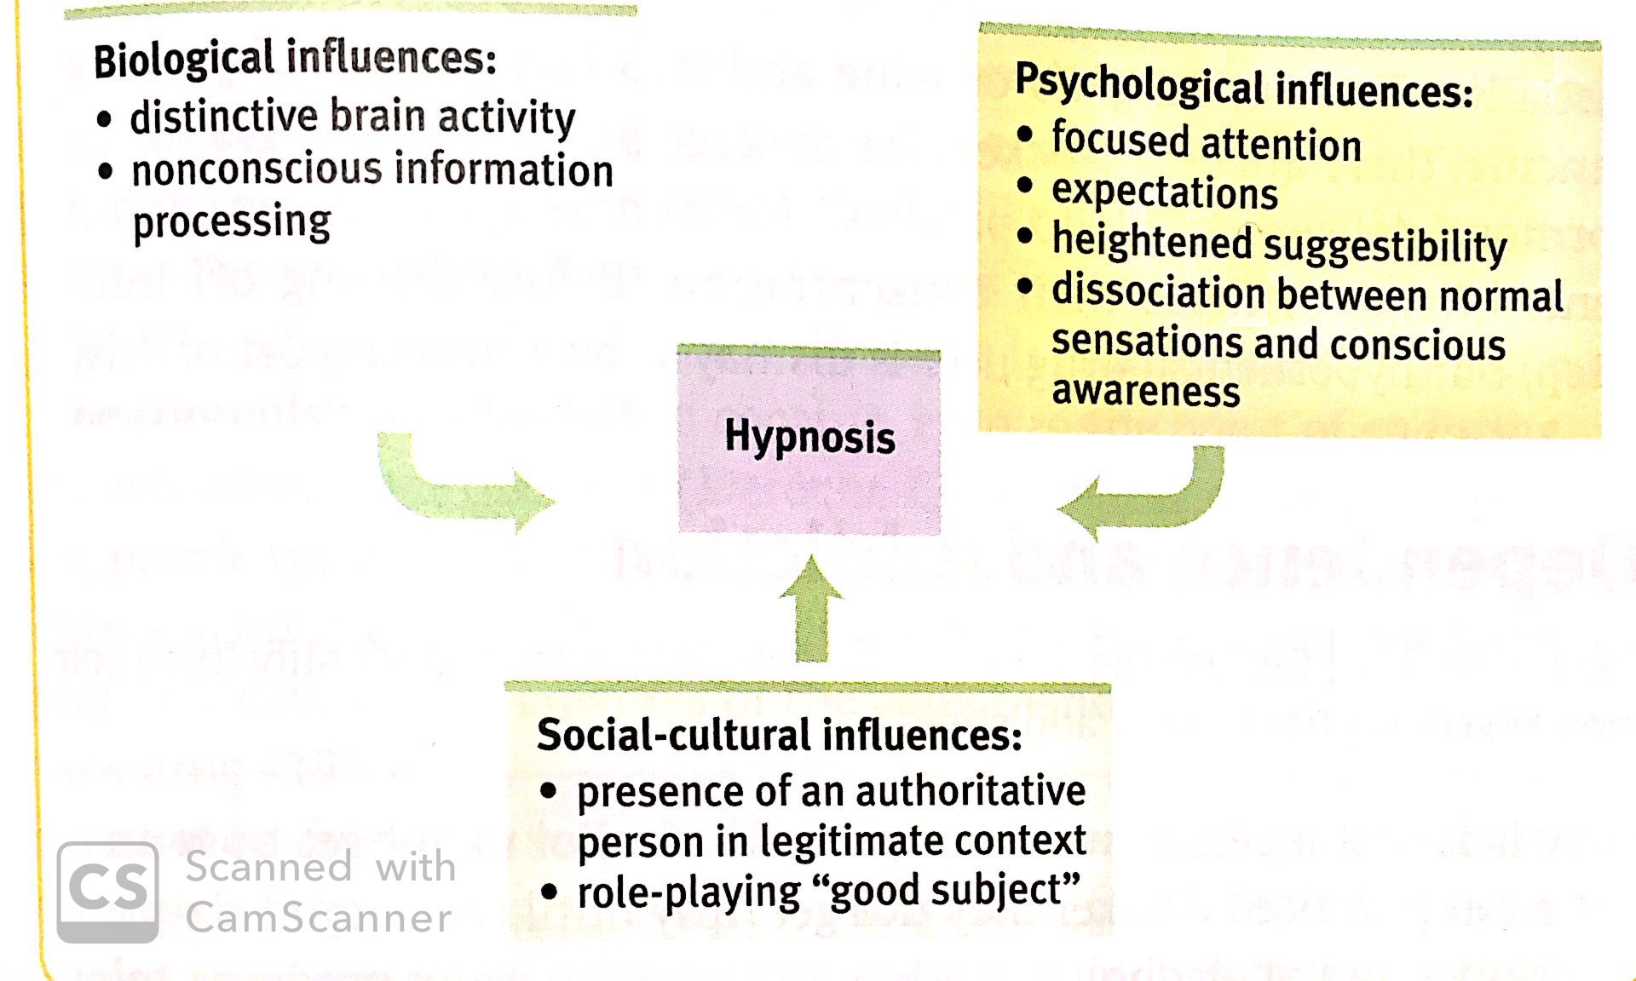

Read Hypnosis techniques in text Pg. 483

Posthypnotic Suggestions – Hypnotic suggestions that the subject will carry out after the hypnosis session has ended. Example – bark like a dog on a prearranged signal.

Applications of Hypnosis:

1. Hypnosis and Memory
There have been instances when individuals recovered seemingly lost memories during hypnosis sessions. Example text – pg.487. However, we need to be cautious about generalizing from these specific cases. First they are quite rare and second, we cannot be sure that hypnosis was the reason for the retrieval – maybe the memory would have come back anyway.
The most substantial problem is that hypnosis is a state of suggestibility. In an effort to please the hypnotist, the subject may inadvertently manufacture untrue details and then later be unable to distinguish the real from the unreal.

2. Hypnosis in therapy
Hypnosis has been used in a variety of therapeutic settings in which subjects have experienced relief with problems ranging from headaches to warts. The problem is that we have no way of knowing for sure that hypnosis caused these improvements. Many studies have shown that people who receive treatment of any kind – even sugar pills – tend to show more improvement than those who receive no treatment, thanks to the power of our positive expectations (placebo effect). Read from text pg.488-89

3. Hypnosis and pain control
Hypnosis does work as a means of pain control. It has a number of practical applications. Examples – nervous dental patients, relieve chronic pain for arthritis, migraine headaches and cancer. Hypnosis techniques may allow people to avoid painkilling drugs, which often have unwanted side effects such as dependence and the loss of mental sharpness.

According to Psychology Today:

Milton H. Erikson said that most people could be hypnotized if the clinician was skillful enough. The current consensus is that about two-thirds of adults are hypnotizable, however, and that this trait is stable over time. A number of measures have been developed to assess hypnotizability, yet, these do not address the question of why one person may be more hypnotizable than another. Although many factors, including empathy, absorption, and expectation of benefit, have been postulated as predictive of hypnotizability, the evidence has been inconsistent.

